# AIM:

To configure PPP encapsulation on serial links and also configure PAP authentication and PPP CHAP authentication. Test the connectivity between all the devices.

# DESCRIPTION:

**PAP:**

Password Authentication Protocol (PAP) is used by PPP links to validate users. PAP authentication requires the calling device to enter the username and password. If the credentials match with the local database of the called device or in the remote AAA database then it is allowed to access otherwise denied**.**

# CHAP:

The Challenge-Handshake Authentication Protocol (CHAP) is an identity checking protocol that periodically re-authenticates the user during an online session.

Properly implemented CHAP is replay attack resistant, and far more secure than the Password Authentication Protocol (PAP).

# CONFIGURATION COMMANDS: ROUTER

Router#conft Router(config)#intfa0/0 Router(config-if)#exit Router(config)#hostnameR1 R1(config)#int fa0/0

R1(config-if)#ip addr 192.16.10.1 255.255.255.0 R1(config-if)#no sh

R1(config-if)#int se2/0

R1(config-if)#ip addr 192.16.20.1 255.255.255.0 R1(config-if)#no sh

R1(config-if)#clock rate 64000

R1(config-if)#ip route 192.16.30.0 255.255.255.0 se2/0

R1(config)#ip route 192.16.40.0 255.255.255.0 se2/0

{Likewise, setup static routing on the other routers} PPP Configuration: R1(config)# interface s0/0/0 R1(config-if)# encapsulation ppp

R2(config)# interface s0/0/1 R2(config-if)# encapsulation ppp R2(config)# interface s0/0/3 R2(config-if)# encapsulation ppp R3(config)# interface s0/0/0 R3(config-if)# encapsulation ppp PAP Configuration:

R1(config)# username R2 secret class

R1(config)# interface se2/0 R1(config-if)# ppp authentication pap

R1(config-if)# ppp pap sent-username R1 password cisco R2(config)# username R1 secret cisco

# PROCEDURE:

1. Make the connections as per the topology and perform static routing.
2. Configure R1 to use PPP encapsulation with R2 and R2 to use PPP with R1 and R3. Likewise, configure R3 to use PPP with R3.
3. Configure PPP-PAP Authentication between R1 and R2.
4. Configure PPP-CHAP Authentication between R2 and R3

# TOPOLOGY DIAGRAM:

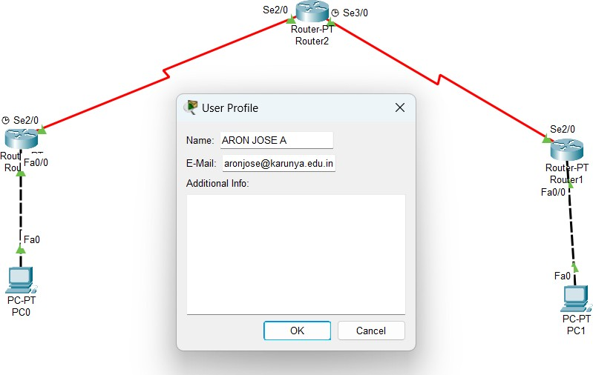

**ADDRESSING TABLE:**

|  |  |  |  |  |
| --- | --- | --- | --- | --- |
| **Device** | **Interface** | **IP Address** | **Subnet Mask** | **Default Gateway** |
| **R0** | **Fa0/0** | **192.16.10.0** | **255.255.255.0** | 192.16.10.1 |
| **Se2/0** | **192.16.20.0** | **255.255.255.0** | 192.16.20.1 |
| **R1** | **Se2/0** | **192.16.20.0** | **255.255.255.0** | 192.16.20.1 |
| **Se3/0** | **192.16.30.0** | **255.255.255.0** | 192.16.30.1 |
| **R2** | **Fa0/0** | **192.16.40.0** | **255.255.255.0** | 192.16.40.1 |
| **Se2/0** | **192.16.30.0** | **255.255.255.0** | 192.16.30.1 |
| **PC0** | **Fa0** | **192.16.10.2** | **255.255.255.0** | 192.16.10.1 |
| **PC1** | **Fa0** | **192.16.40.2** | **255.255.255.0** | 192.16.40.1 |

# OUTPUT

**Screenshot of successful ping between PCs:**



# Screenshot of show running-config of all 3 routers: Router 0:

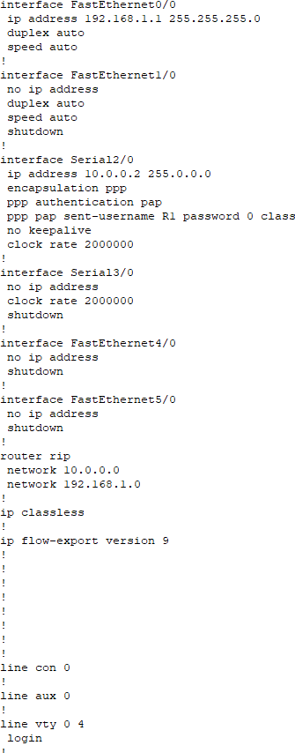

**Router1:**

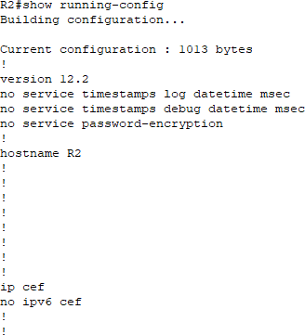

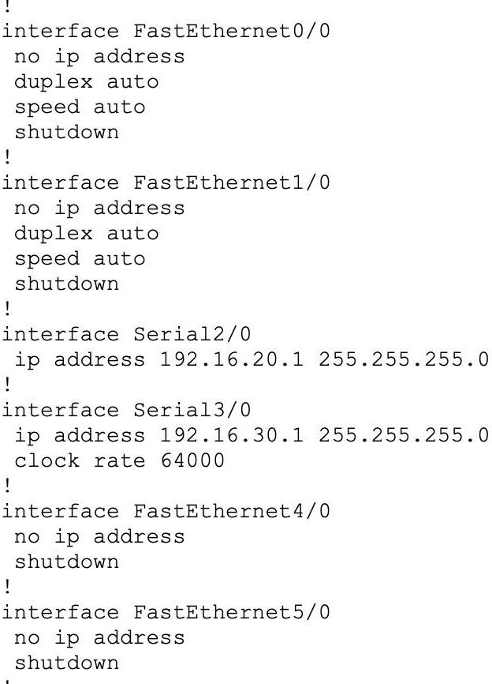

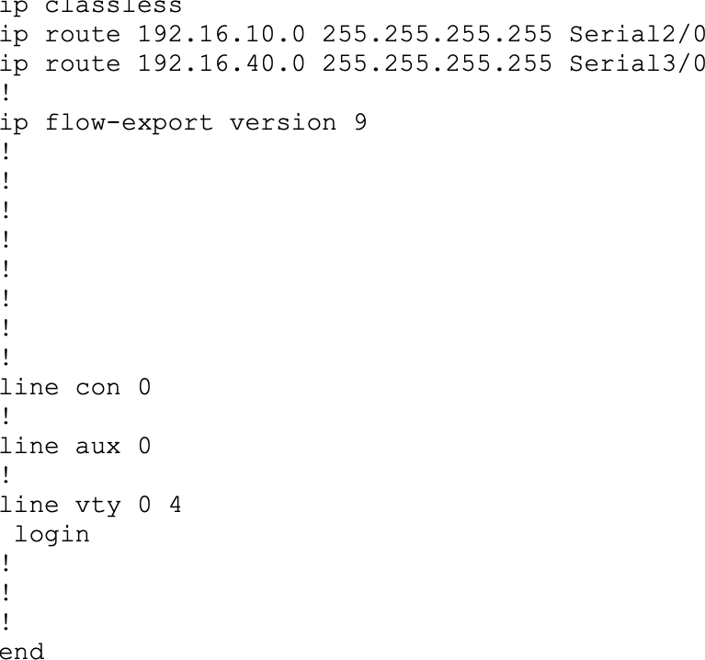

# Router2:

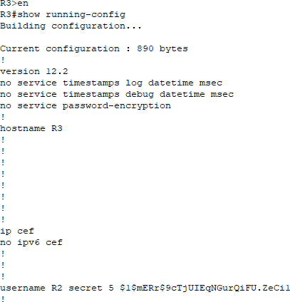

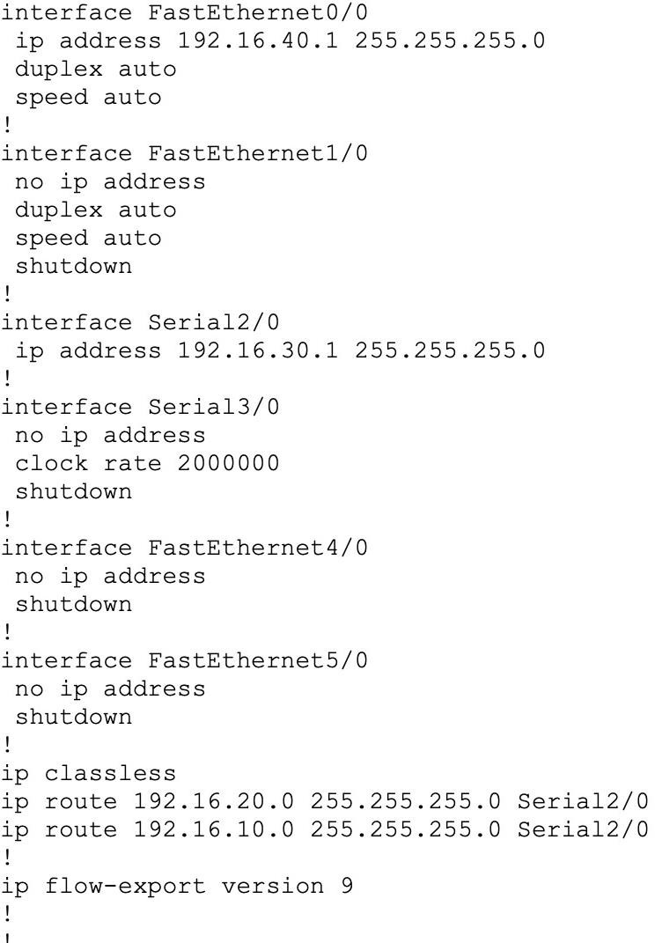

**Screenshot of show ip int brief:**

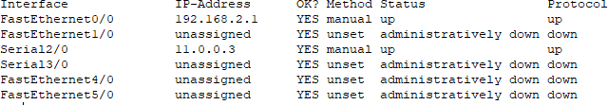

# Screenshot of show controller se2/0

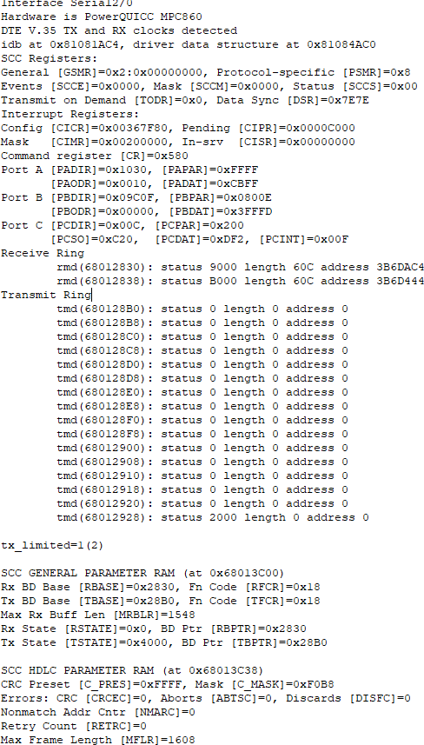

**Screenshot of show int se2/0**

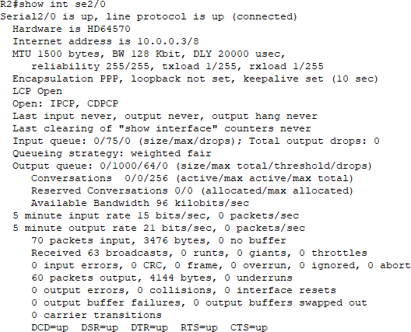

# RESULT:

The experiment to configure PPP Encapsulation on serial links and also configure PPPPAP Authentication and PPP-CHAP Authentication using Cisco Packet Tracer has been performed successfully.